**Report on**

**Needs Survey relating to International Schools for Highly Skilled International Professionals**

**March, 2024**

**Osaka Prefecture, Osaka City**

**(Survey Contractors: Hankyu Hanshin Properties Corp.)**

**Contents**

I．Survey Outline 1

１．Purpose 1

２．Overview 1

（１）Target 1

（２）Method 1

（３）Period 1

（４）Survey Items 1

３．Aggregation Method 2

（１）Simple Aggregation 2

（２）Cross Aggregation 2

（３）Free comments 2

４．Overview of Results 2

II．Points of Survey Results 3

１．Attributes of Respondents 3

２．Facts about international schools their children currently attend and their future needs 3

２-１．Facts about international schools their children currently attend 3

２-２．Needs in the case of sending one’s children to an international school 4

３．Preferences in working overseas 4

４．Progress to a higher education at universities 5

III．Survey Results 7

１．Attributes of Respondents 7

（１）Age 7

（２）Gender 9

（３）Employer to work for 11

（４）Individual Annual Income 13

（５）Annual Household Income 15

（６）Family Structure 17

（７）Type of school one’s children attend 19

（８）Intention/preference of switching to an international school 21

２．Facts about the international schools currently attended and their future needs 23

２-１．Facts about the international schools currently attended... 23

（１）Type of the international school currently attended 23

（２）Course of study when one’s child was enrolled in an international school 25

（３）Distance to the international school (Assuming one uses public transportation) 27

（４）Tuition per student per year 29

（５）Main language used in class 31

（６）Important factors in selecting a school 33

２-２．Needs in the case of sending one’s children to an international school 35

（１）Preference for the type of school in case of switching to an international school 35

（２）Preferred course of study to enroll one’s children in case of switching to an international school 36

（３）Preferred distance to the international school (Assuming one uses public transportation) 37

（４）Preferred tuition per student per year 38

（５）Preference for the language mainly used in class 39

（６）Important factors in selecting a school 41

３．Preferences in working overseas 43

（１）Preferred location of work 43

（２）The authority to make decisions about work transfers within the family 45

（３）Possibility of accompaniment by family members in case of working abroad 47

（４）Important factors in the living environment 49

（５）Significance of the educational environment in the location of transfer 51

（６）Preference for schools for one’s children to attend in case of working overseas 53

（７）Provision of assistance by the employer for international school attendance 55

４．Advancement to a higher education at university 57

５．Other free comments 59

IV．Questionnaire 62

１．Japanese version 62

２．English version 69

I．Survey Outline

１．Purpose

〇 A survey was conducted to understand the needs for international schools for highly skilled international professionals. The survey results will be used as the basic information to invite foreign financial companies to Osaka and to establish living conditions.

２．Overview

（１）Target

〇 We surveyed those earning JPY15,000,000 or higher per annum, assuming highly skilled professionals are most likely to work with international financial companies.

〇　We selected countries/regions (UK, Hong Kong, India, Singapore and China) which have developed as global financial cities where a number of highly skilled professionals are expected to live and many companies have potential to be invited to Osaka. Then we surveyed those living in these countries/regions.

（２）Method

〇 The online survey was conducted for those registered overseas with the web survey company (GMO research＆AI, Inc.) to answer the questionnaire.

〇 Language: English only

（３）Period

〇 March 21, 2024 – March 29, 2024

（４）Survey Items

〇 Attributes of respondents (Age, Gender, Employer to work for, Individual annual income, Annual household income, Family structure, School for children, Intention/preference of switching to an international school)

〇 Facts about the international school one’s children currently attend (Type of school, Course of study one’s child was enrolled in, Distance to the international school, Tuition, Language used in class, Factors they considered important when selecting a school)

〇 Needs in the case of sending children to an international school (Type of school, Course of study to enroll one’s children, Distance to the international school, Tuition, Language used in class, Factors they consider important in selecting a school)

〇 Preferences in working overseas (Preferred location of work, the authority to make decisions about work transfers, accompaniment by family when getting transferred, the most important factors in the living environment, significance of the educational environment in the location of transfer, schools for children in case of working overseas, assistance provided by the employer for international school attendance)

〇 Preference for advancing to a higher education at university

〇 Free comments and remarks

３．Aggregation Method

（１）Simple Aggregation

〇　Compositions and graphs are shown for all questions. As numbers lower than the second decimal point are rounded for compositions, the total does not become 100% if the numbers are added together.

〇 For “Family structure”, we aggregated numbers in 4 items: “Single”, “Spouse + No Children”, ”Spouse + Children” and “Single + Children”.

〇 In asking questions about “important factors when selecting a school” for those who have their children attend international schools and those who do not, we used the weighted average method where weighted points are allocated to the top three options and points of each option are divided by the number of respondents. The rule of allocating points is: to add 3 points to “the first option”, 2 points to the second and 1 point to the third.

（２）Cross Aggregation

〇 We cross-aggregate and analyze data of respondents’ “Country/Region”, “Employer to work for” and “Annual household income”. In case the number of respondents is not large enough to obtain statistical usability, we do not analyze data but show the aggregate results only.

（３）Free comments

〇 We categorize the comments into several groups. If one comment falls under several groups, we divide the comment into several segments and apply each to a relevant category.

４．Overview of Results

〇 Number of responses　425 (Target:　300)

|  |  |  |  |  |  |  |
| --- | --- | --- | --- | --- | --- | --- |
| Country | United Kingdom | Hong Kong | India | Singapore | China | Total |
| Target number | 60 | 60 | 60 | 60 | 60 | 300 |
| Actual number | 88 | 86 | 79 | 87 | 85 | 425 |
| Attainment rate | 146.7％ | 143.3％ | 131.7％ | 145.0％ | 141.7％141.7 | 141.7％ |

II．Points of Survey Results

１．Attributes of Respondents

〇 In terms of “Age”, “30-39” and “40-49” account for 60% of all respondents. In India “20-29” is the largest age bracket.

〇 In terms of “Gender”, “male” accounts for 60% while “female” for 40%.

〇 In terms of “Employer to work for”, “Other” accounts for 40%, which is the largest, followed by “Finance, Insurance” (20%). In UK, “Finance, Insurance” accounts for the largest proportion (30%), while in China “Academic research, professional and technical services” is the largest (25%).

〇 In terms of “Individual annual income”, 50% responded “less than 2,5000,000JPY”. In China, “40,000,000JPY or higher” accounts for a large proportion (10%).

〇 In terms of “Annual household income”, “Less than 30,000,000JPY” accounts for 70%. In China, “40,000,000JPY or higher” accounts for a large proportion (40%).

〇 In terms of “Family structure”, “Spouse and children” is the largest group (40%). In UK, “Spouse and children” accounts for the largest proportion (50%), while in Hong Kong “Single” is the largest (40%).

〇 In terms of “Type of school one’s children go to” (asked to households with children only), 60% responded “All or some of my children go to an international school”, which in China accounts for 80%. In Singapore, 60% responded “all of my children go to a local school”.

〇 In terms of “Intention/Preference of switching to an international school” (asked to households that have all of their children attend a local school), 60% responded they are “considering” switching to an international school. In UK, even more responded they are “considering” (70%).

２．Facts about international schools their children currently attend and their future needs

2ー1. Facts about international schools their children currently attend

〇 In terms of “Type of school (commuter/boarding)”, 70% responded “Commuter school” and 30% “Boarding school”. In Hong Kong, 90% responded “Commuter school”.

〇 In terms of “the course of study when one enrolled children in an international school” (asked to households that use boarding schools), the largest group enrolled their children from “Elementary school equivalent” (40%), followed by “High school equivalent” (30%).

〇 In terms of “Distance to the international school” (asked to households that use a commuter school), 70% responded the commute is “Less than 1 hour”. In Singapore, “Less than 1 hour and 30 minutes” accounts for a large proportion.

〇 In terms of “Tuition per student per year”, the largest group answered “Less than 30,000 USD” (30%) followed by “less than 20,000 USD” (20%). In India “Less than 10,000 USD” accounts for the largest proportion (30%). Overall respondents expect lower tuitions in India. In Singapore, on the other hand, more than half of the respondents responded “Less than 30,000USD, which means they expect to pay a higher amount.

〇 In terms of the “Main language to be used in class”, “English” accounts for 80%. In UK and India, English is used in almost every class. In Greater China such as China and Hong Kong, “Local language” accounts for a large proportion (25%).

〇 In terms of “Important factors in selecting a school”, “Curriculum adopted by the school”, ”Quality of teaching staff” and ”International certifications held by the school” are prioritized.

2－2．Needs in the case of sending one’s children to an international school

〇 In terms of “Type of school (commuter/boarding)”, half of the respondents like to use a “Commuter school”, 20% a “Boarding school”, and 30% responded “Either is fine”.

〇 In terms of “Preferred type of school in case of switching to an international school” (asked to households that prefer a boarding school), the largest group want to use one from “High school equivalent” (60%), followed by “Junior high school equivalent” (30%).

〇 In terms of “Distance to the international school” (asked to households that prefer a “Commuter school” or answered “Either is fine”), 90% responded “Less than 1 hour” for a commute.

〇 In terms of “Tuition per student per year”, 30% responded “Less than 20,000 USD” and another 30% responded “Less than 30,000 USD.

〇 In terms of the “Language mainly used in class”, most respondents prefer “English” and less than 10% prefer “Local languages”.

〇 In terms of “Important factors in selecting a school”, “Quality of teaching staff” is the top priority, followed by the “Good for getting into university”.

３．Preferences in working overseas

〇 As for the question “Please tell us where you would like to work”, “Europe” and “Other Asia countries than Japan” account for 40% each. In UK, “Europe” marks a high percentage (80%) among the respondents. In Hong Kong and Singapore, “Other Asian countries than Japan” (marked 60% for each) are most preferred.

〇 As for “Who has the authority to make decisions about work transfers within the family?”, 90% responded “If I had to choose, I do”.

〇 As for the question “If you were to work abroad, would you be accompanied by family or go alone?”, 70% responded “I would probably be accompanied by my family”. In India, more responded they would be “probably accompanied” by their families (80%).

〇 As for the question “What is the most important to you about the living environment of your overseas workplace?”, “Residential environment” marks the highest point (60%), followed by “Medical treatment environment” (20%). In UK, “Educational environment” accounts for a large proportion (20%) while in China “Medical treatment environment” resulted in a high percentage (50%).

〇 As for “How important is the educational environment of the place you are transferring to for you?”, “Very important” and “Important” account for 80% of all respondents. In UK, even more responded either “Very important” or “Important” (90%).

〇　As for “Assuming you would like your child to attend school at your overseas workplace, would you prefer a local school or an international school?”, 60% answered “International school”. In India, “International school” accounts for an even larger proportion (80%).

〇　As for “Does your employer provide any assistance for international school attendance?”, many responded “Yes” (60%) and a few responded “No” (30%). In China, a high percentage of respondents answered “Yes” (90%).

４．Progress to a higher education at universities

〇 As for “preferred universities to go to”, “Prestigious universities in Europe/U.S.” makes up the largest proportion (70%), followed by “Other public universities in Europe/U.S.” (40%). In UK, “Prestigious universities in Europe/U.S.” accounts for a large proportion. In India, "Prestigious universities in Europe or the U.S." (70%) accounts for the largest proportion, followed by "Other public universities in Europe or the U.S." (50%) and "Prestigious Japanese universities" (45%).

III．Survey Results

１．Attributes of Respondents

（１）Age　〔SA / n=425〕

Question：Please tell us your age.

***Overall***

〇 “30-39” (32.5%) is the largest age bracket, followed by “40-49” (26.8%).

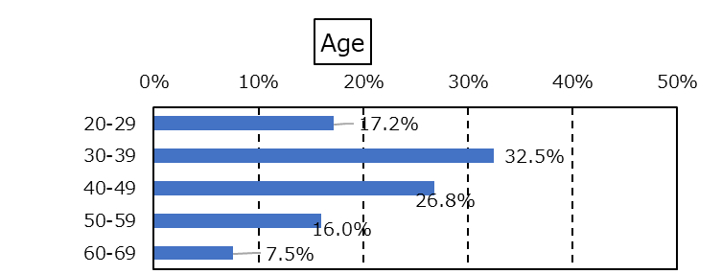

***By Country/Region***

〇 In India, “30-39” or younger age brackets account for more than 60%, which is the largest age group.

〇 In UK, “30-39” accounts for a large proportion (43.2%).

***By Employer to work for***

〇 The “20-29” age range makes up the largest proportion in “Finance, Insurance” and “Telecommunication” (24.2% and 25% respectively).

***By Annual household income***

〇 No specific tendencies are seen here.





（２）Gender　〔SA / n=425〕

Question：Please tell us your gender.

***Overall***

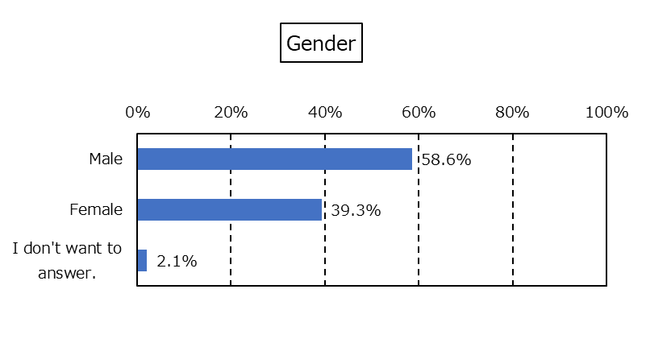〇 “Male” accounts for 60% and “Female” accounts for 40%.

***By Country/Region***

〇 In Hong Kong, “Female” accounts for a large proportion (44.2%).

***By Employer to work for***

〇 In Manufacturing, “Male” accounts for a large proportion (70.3%).

〇 In Telecommunication and freelancing, “Female” exceeds “Male”.

***By Annual household income***

〇 The “Female” ratio exceeds that of “Male” among households with an annual household income of 50,000,000 JPY or more.



 （３）Employer to work for　〔SA / n=425〕

Question：Please tell us which of the following most accurately describes the employer you work for.

***Overall***

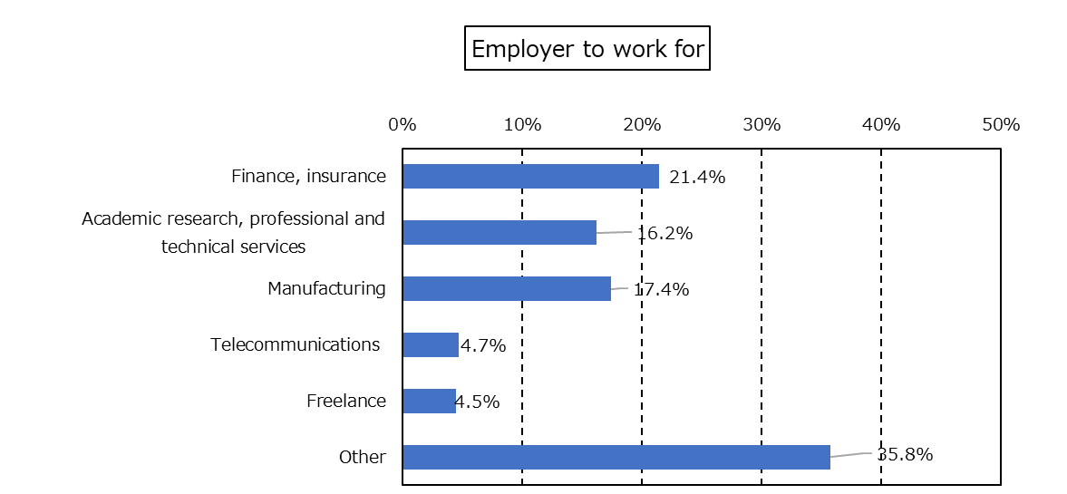〇 “Other” accounts for the largest proportion (35.8%), followed by “Finance, Insurance” (21.4%).

***By Country/Region***

〇 “Finance, Insurance” accounts for a large proportion (28.4%) in UK.

〇 “Academic research, professional and technical services” accounts for a large proportion (24.7%) in China.

***By Employer to work for***

〇 No contents to show here.

***By Annual household income***

〇 Among households with an annual income range of “40,000,000 JPY to 50,000,000 JPY”, “Manufacturing” accounts for a large proportion (30.0%).”



（４）Individual Annual Income　〔SA / n=425〕

　Question：Please tell us your individual annual income.

***Overall***

〇 “15,000,000 JPY to less than 20,000,000 JPY” accounts for the largest proportion (43.3%), followed by “20,00,000 JPY to less than 25,000,000 JPY” (19.8%).

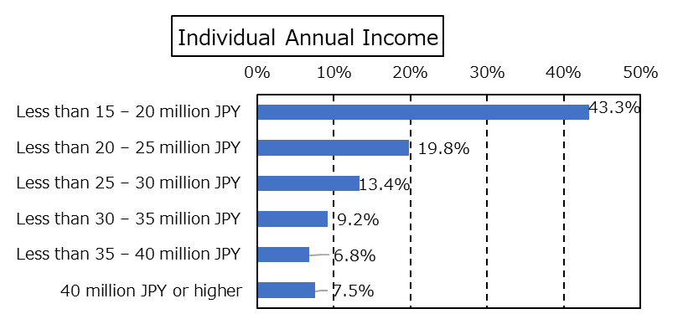

***By Country/Region***

〇 Overall, in China, high income earners make up a large proportion, especially those earning “40,000,000 JPY or higher” (12.9%) make up the largest.

***By Employer to work for***

〇 Individuals earning “20,000,000 JPY to less than 25,000,000 JPY” account for a large proportion (35.0%) in Telecommunication.

***By Annual household income***

〇 No specific tendencies are seen here.



（５）Annual Household Income 〔SA / n=425〕

Question：Please tell us your annual household income.

***Overall***

〇 “20,000,000 JPY to less than 30,000,000 JPY” accounts for the largest proportion (25.4%), followed by “15,000,000 JPY to less than 20,000,000 JPY” (23.5%).

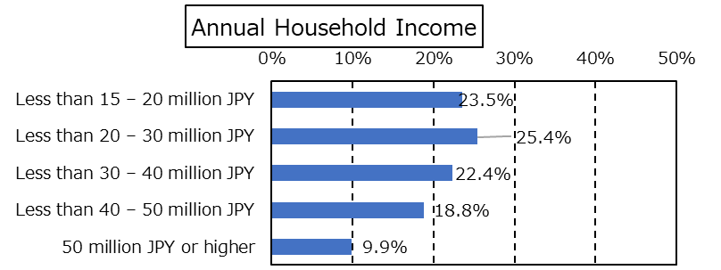

***By Country/Region***

〇 In China, “40,000,000 JPY to less than 50,000,000 JPY” accounts for a large proportion (28.2%).

***By Employer to work for***

〇 “20,000,000 JPY to less than 30,000,000 JPY” accounts for a large proportion (40.0%) in Telecommunication.

***By Annual household income***

〇 No contents to show here.





（６）Family Structure 〔MA / n=425〕

Question：Please tell us about your family structure.

***Overall***

〇 “Spouse + children” accounts for the largest proportion (37.6%), followed by “Single + Children” (26.8%).

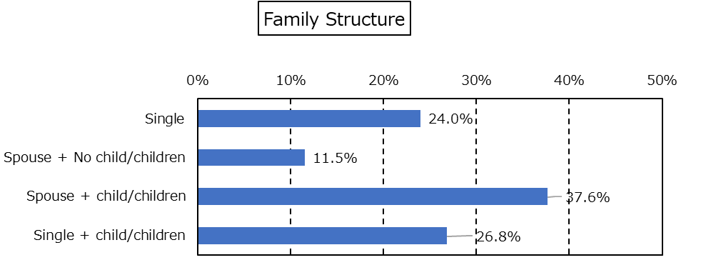

***By Country/Region***

〇 “Single” accounts for a large proportion (37.2%) in Hong Kong.

〇 “Spouse + children” accounts for a large proportion (53.4%) in UK.

***By Employer to work for***

〇 “Spouse + children” accounts for a large proportion (50%) in Manufacturing.

〇 “Single + children” accounts for a large proportion (47.4%) among freelancers.

***By Annual household income***

〇 “Spouse + children” accounts for a large proportion (46.3%) among the “40,000,000 JPY to less than 50,000,000 JPY” income bracket.







**The following question was directed to those who responded they have “children” for Question (6) Family Structure**

（７）Type of school one’s children attend　〔SA / n=274〕

Question：Do your children attend an international school?

【Overall】

〇 “All of my children attend an international school” (37.6%) and “Some of my children attend an international school” (22.6%) account for more than 60% together.

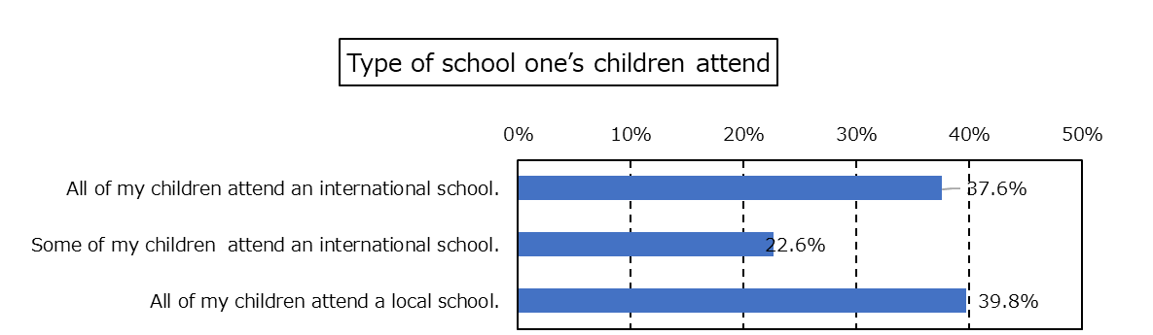

【By Country/Region】

〇 In China, “All of my children attend an international school”（42.9%）and “Some of my children attend an international school”（42.9%）account for more than 80% together.

〇 In Singapore, “All of my children attend a local school” (63.5%) accounts for a large proportion.

【By Employer to work for】

〇 In Manufacturing, “All of my children attend an international school” makes up a large proportion (45.8%).

〇 In Academic research, professional and technical services, “Some of my children attend an international school” accounts for a high ratio (44.4%). Put together with “All of my children attend an international school” (37.8%), more than 80% of the respondents have their children attend an international school.

【By Annual household income】

〇 Among households earning 40,000,000 JPY to less than 50,000,000 JPY, “All of my children attend an international school” accounts for a large proportion (51.7%).

〇 Among households earning 50,000,000 JPY or more, “All of my children attend a local school” accounts for a large proportion (50.0%).

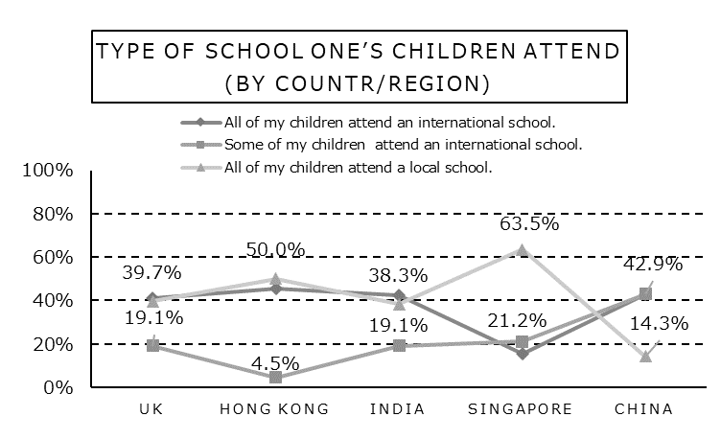

**The following question was directed to those who responded “All of my children attend a local school” for Question (7) Type of school one’s children attend.**

（８）Intention/preference of switching to an international school　〔SA / n=109〕

Question：Are you considering changing your child’s school to an international school?

***Overall***

〇 “I am considering it” (59.6%) accounts for more than half of all responses.

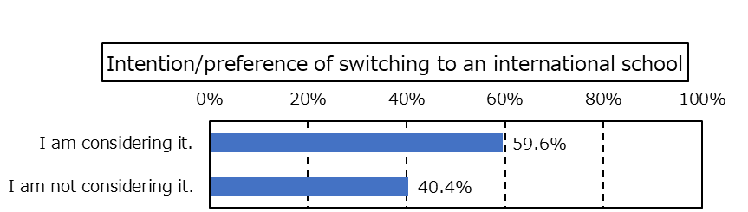

***By Country/Region***

〇 In UK, “I am considering it” accounts for a large proportion (70.4%).

***By Employer to work for***

〇 In Academic research, professional and technical services, “I am considering it” accounts for 70%.

〇 Among freelancers, 0% responded “I am considering it”.

***By Annual household income***

〇 Among households earning 30,000,000 JPY to less than 40,000,000 JPY, “I am considering it” accounts for a large proportion (70.4%).



２．Facts about the international schools currently attended and their future needs

**The following (1) - (6) questions were directed to those respondents who answered ”All of my children attend an international school” or “Some of my children attend an international school” for Question 1. (7) Type of school one’s children attend.**

2－1．Facts about the international schools currently attended

（１）Type of the international school currently attended　〔SA / n=165〕

Question：Is the international school your child currently attends a commuter school or a boarding school?

***Overall***

〇 “Commuter school” (73.9%) accounts for a larger proportion than that of “Boarding school” (26.1%).

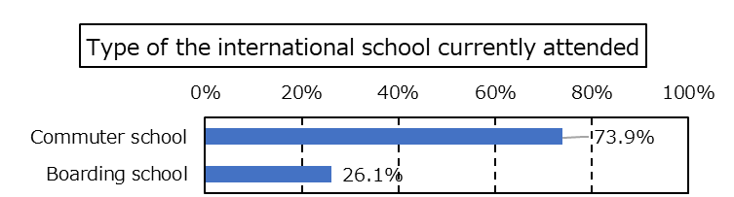

***By Country/Region***

〇 In Hong Kong, “Commuter school” accounts for 90%.

***By Employer to work for***

〇 In Telecommunication, “Commuter school” accounts for 100%.

***By Annual household income***

〇 “Boarding school” accounts for a large proportion (40.0%) among households earning 50,000,000 JPY or more.

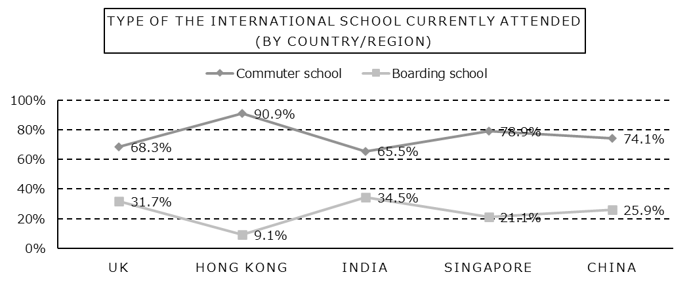





**The following question was directed to those who responded “Boarding school” for Question (1) Type of international school currently attended.**

（２）Course of study when one’s child was enrolled in an international school　〔SA / n=43〕

Question：From what course of study did you enroll your child in?

***Overall***

〇 “Elementary school equivalent” accounts for the largest proportion (37.2%), followed by “High school equivalent” (30.2%).

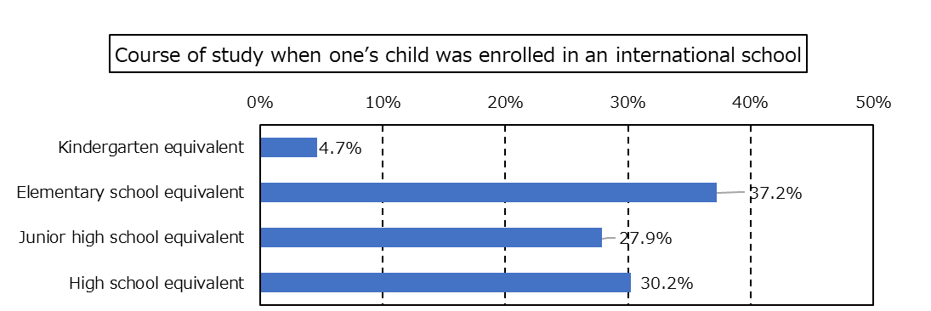

*As we do not have enough parameters to obtain usability based on cross aggregation, we did not conduct analyses. Only the results are shown here.



**The following question was directed to those who responded “Commuter school” for Question（１）Type of international school currently attended.**

（３）Distance to the international school（Assuming one uses public transportation）〔SA / n=122〕

Question：What is the distance to the international school in terms of access time (assuming public transportation)?

***Overall***

〇 “Less than 1 hour” accounts for 70%, where “30 minutes to less than 1 hour” (50.8%) constitutes the largest proportion, followed by “Less than 30 mins” (21.3%).

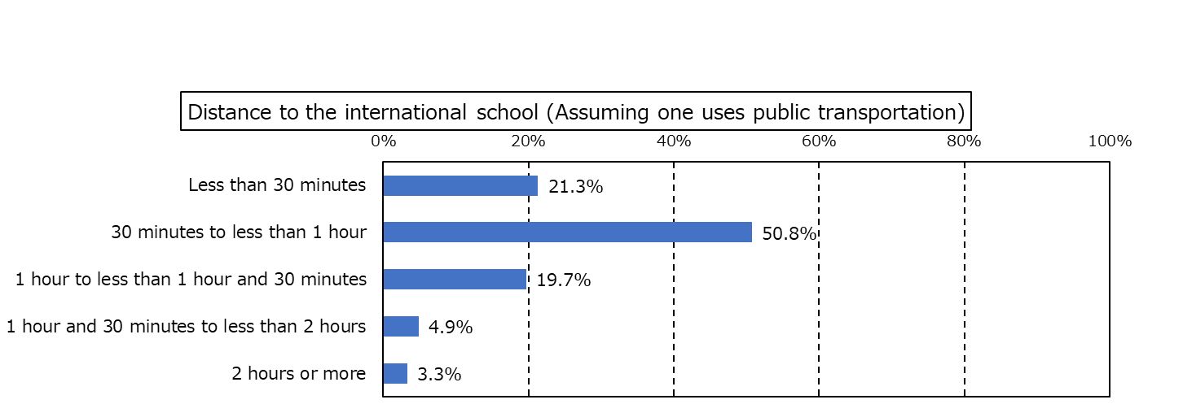

***By Country/Region***

〇 In Singapore and China, “Less than 30 minutes” accounts for a small proportion, while “1 hour to less than 1 hour 30 minutes” accounts for a large proportion.

***By Employer to work for***

〇 “30 minutes to less than 1 hour” accounts for a large proportion in Finance and Insurance (57.1%), Academic research, professional and technical services (66.7%) and Manufacturing (51.6%).

〇 In Telecommunication, “Less than 30 minutes” accounts for a large proportion (40.0%).

〇 Among freelancers, “1 hour and 30 minutes to less than 2 hours” accounts for a large proportion (66.7%).

***By Annual household income***

〇 Among households earning 15,000,000 JPY to less than 20,000,000 JPY, “30 minutes to less than 1 hour” accounts for a large proportion (70.6%).



（４）Tuition per student per year　〔SA / n=165〕

Question：In choosing an international school, how much did you expect tuition (not including boarding fees, etc.) to cost per student per year?

***Overall***

〇 “Less than 30,000 USD” accounts for the largest proportion (30.3%), followed by “Less than 20,000 USD” (20.6%).

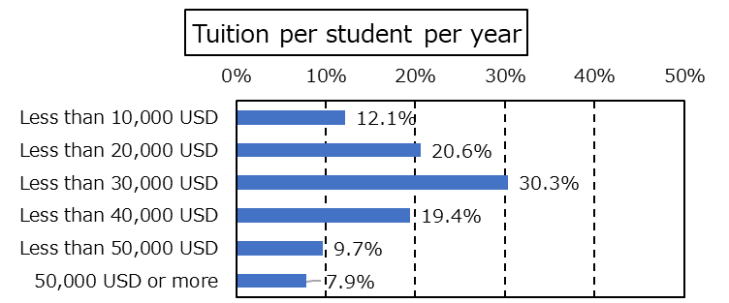

***By Country/Region***

〇 In India, “Less than 10,000 USD” accounts for a large proportion (31.0%).

〇 In Singapore, “Less than 30,000 USD” accounts for a large proportion (47.4%).

***By Employer to work for***

〇 In Telecommunication, “Less than 30,000 USD” accounts for a large proportion (80.0%).

〇 Among freelancers, “50,000 USD or more” accounts for a large proportion (22.2%).

***By Annual household income***

〇 Among households earning 15,000,000 JPY to less than 20,000,000 JPY, more than 60% responded “Less than 20,000 USD”.

〇 Among households earning 50,000,000 JPY or more, more than 50% responded “Less than 50,000 USD”.

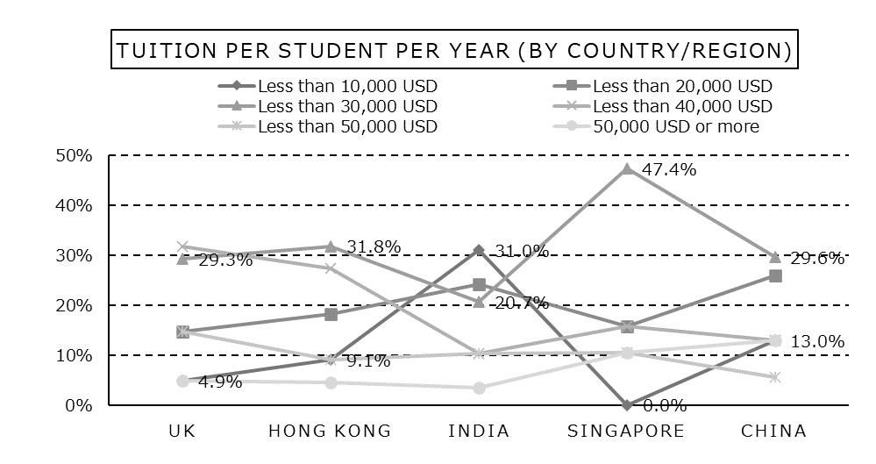



（５）Main language used in class　〔SA / n=165〕

Question：Which language is the main language used in class?

***Overall***

〇 “English” accounts for the majority of all responses (84.2%), while “local languages” a small proportion (13.9%).

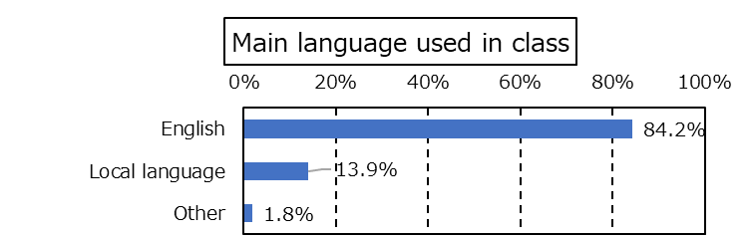

***By Country/Region***

〇 In UK and India, almost all respondents answered “English”.

〇 In China and Hon Kong, “Local languages” account for a large proportion.

***By Employer to work for***

〇 Among freelancers, “Local languages” accounts for a large proportion (22.2%).

***By Annual household income***

〇 No specific tendencies are seen here.

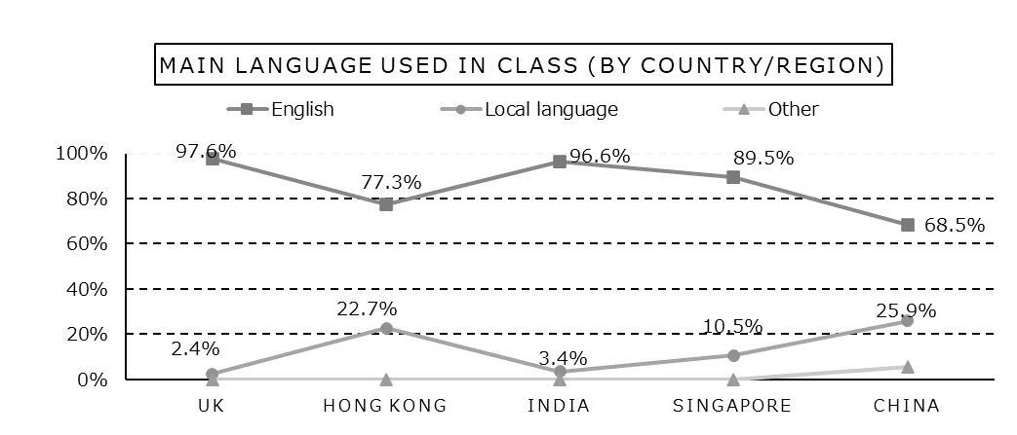



（６）Important factors in selecting a school　〔MA / n=165〕

Question：Please select the top three factors (top 3) that were important to you in selecting a school.

Note：For this question, we used the weighted average method where weighted points are allocated to the top three options and points of each option are divided by the number of respondents. The rule of allocating points is: to add 3 points to “the first option”, 2 points to the second and 1 point to the third.

***Overall***

〇 “Curriculum adopted by the school” marks the highest points (1.0 points), followed by “Quality of teaching staff” and ”International certifications held by the school” (0.9 points).

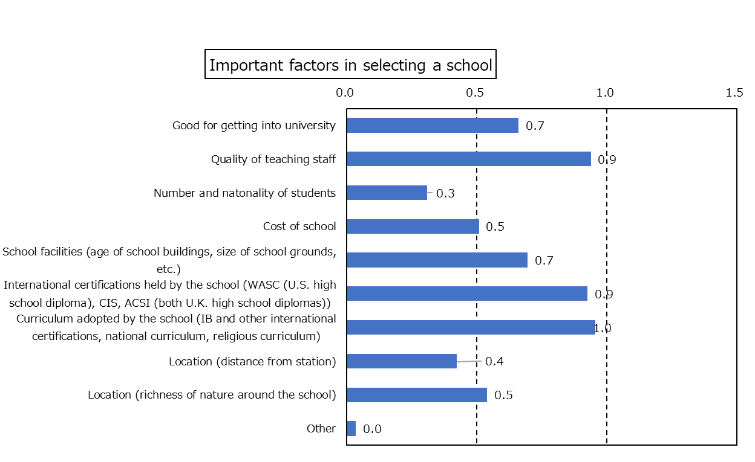

***By Country/Region***

〇 In Hong Kong, “Quality of teaching staff” marks a high point (1.4 points).

〇 In Singapore, “International certifications held by the school” marks a high point (1.2points).

***By Employer to work for***

〇 In Academic research, professional and technical services, “Quality of teaching staff” marks a high point (1.2 points).

〇 Among freelancers, “International certifications held by the school” marks a high point (1.8 points).

***By Annual household income***

〇 Among households earning 15,000,000 JPY to less than 20,000,000 JPY, “Good for getting into university” and “Quality of teaching staff” marks a high point (1.1 points).

〇 Among households earning 50,000,000 JPY or more, “Quality of teaching staff” and “International certifications held by the school” marks a high point (1.1 points).





**The following (1) – (6) were directed to those who responded “All of my children attend a local school” for (7)** **Type of school one’s children attend and “I am considering it“ for (8) Intention/preference for switching to an international school.**

2－2．Needs in the case of sending one’s children to an international school

（１）Preference for the type of school in case of switching to an international school　〔SA / n=65〕

Question：If you change your child’s school to an international school, would you prefer a commuter school or a boarding school?

***Overall***

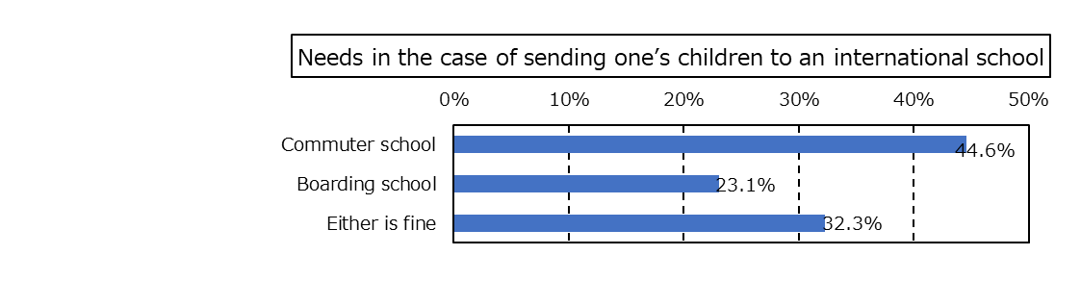〇 “Commuter school” accounts for the largest proportion (44.6%), followed by “Either is fine” (32.3%).

*As we do not have enough parameters to obtain usability based on cross aggregation, we did not conduct analyses. Only the results are shown here.



**The following question was directed to those who responded “Boarding school” for (1) Preference for the type of school in case of switching to an international school**

（２）Preferred course of study to enroll one’s children in case of switching to an international school　〔SA / n=15〕

Question：What course of study do you plan to enroll your child in?

***Overall***

〇 “High school equivalent” accounts for the largest proportion (60.0%), followed by “Junior high school equivalent” (26.7%).

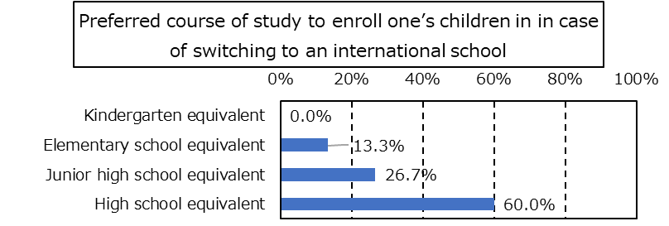

*As we do not have enough parameters to obtain usability based on cross aggregation, we did not conduct analyses. Only the results are shown here.



**The following question was directed to those who responded “Commuter school” or “Either is fine” for Question（１）Preference for the type of school in case of switching to an international school.**

（３）Preferred distance to the international school　〔SA / n=50〕

Question：How far do you expect to be to the international school in terms of access time (assuming one uses public transportation)?

***Overall***

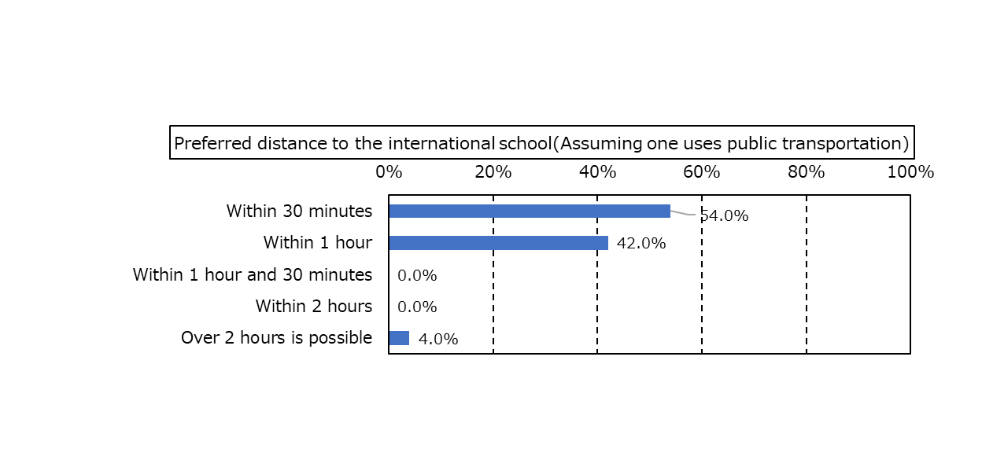〇 “Within 30 minutes” (54.0%) accounts for the largest proportion, followed by “Within 1 hour” (42.0%).

*As we do not have enough parameters to obtain usability based on cross aggregation, we did not conduct analyses. Only the results are shown here.

（４）Preferred tuition per student per year　〔SA / n=65〕

Question：What is your expected tuition per student per year (not including dormitory fees, etc.)?

***Overall***

〇 “Less than 20,000 USD” (30.8%) and “Less than 30,000 USD” (30.8%) account for the largest proportion, followed by “Less than 10,000 USD” (16.9%).

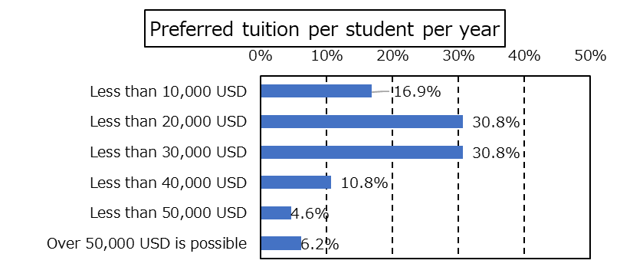

*As we do not have enough parameters to obtain usability based on cross aggregation, we did not conduct analyses. Only the results are shown here.







（５）Preference for the language mainly used in class　〔SA / n=65〕

Question：Which language would you like the main language used in class to be?

***Overall***

〇 “English” (87.7%) accounts for the majority of all responses while “Local languages” a small proportion (9.2%).

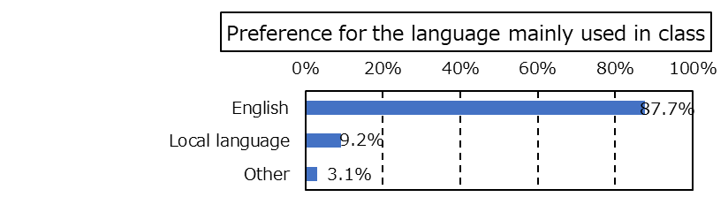

*As we do not have enough parameters to obtain usability based on cross aggregation, we did not conduct analyses. Only the results are shown here.





（６）Important factors in selecting a school　〔MA / n=65〕

Question：Please select the top 3 things (top 3) that are important to you in selecting a school.

Note：For this question, we used the weighted average method where weighted points are allocated to the top three options and points of each option are divided by the number of respondents. The rule of allocating points is: to add 3 points to “the first option”, 2 points to the second and 1 point to the third.

***Overall***

〇 “Quality of teaching staff” (1.0 point) marks the highest point, followed by “Good for getting into university” (0.9 point).

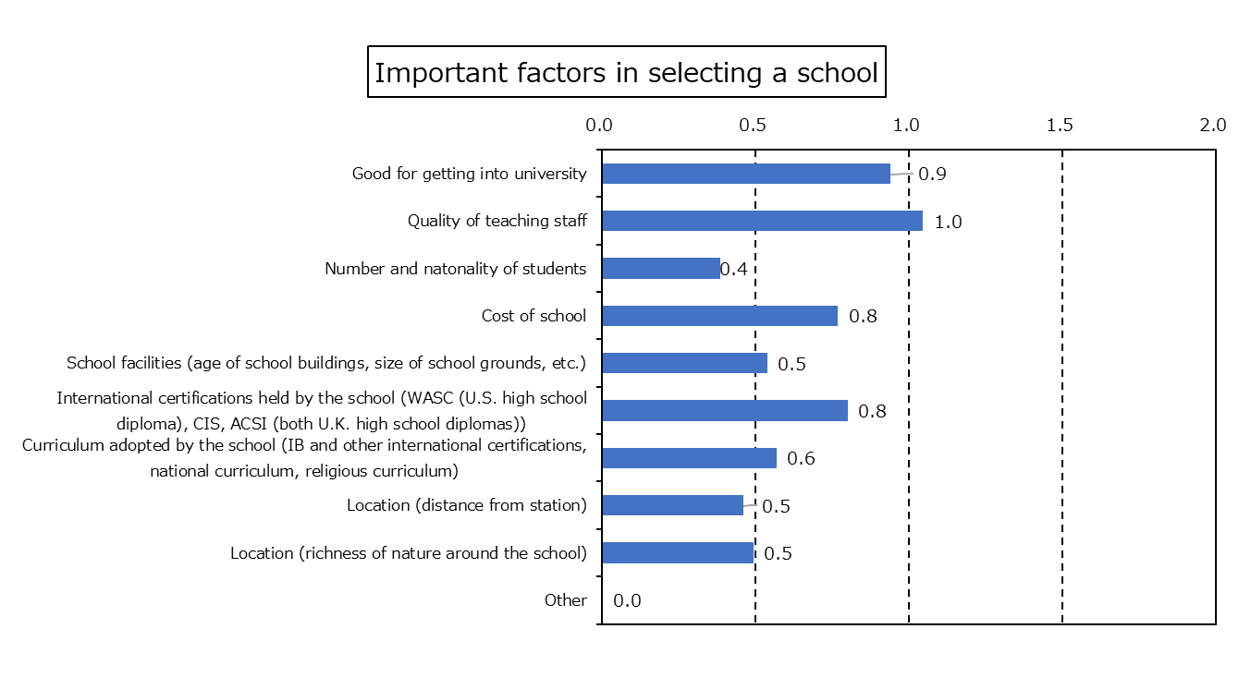

*As we do not have enough parameters to obtain usability based on cross aggregation, we did not conduct analyses. Only the results are shown here.





３．Preferences in working overseas

（１）Preferred location of work　〔MA / n=425〕

　Question：Please tell us where you would like to work.

***Overall***

〇 “Asia (outside Japan)” (42.6%) accounts for the largest proportion, followed by “Europe (39.5%)”.

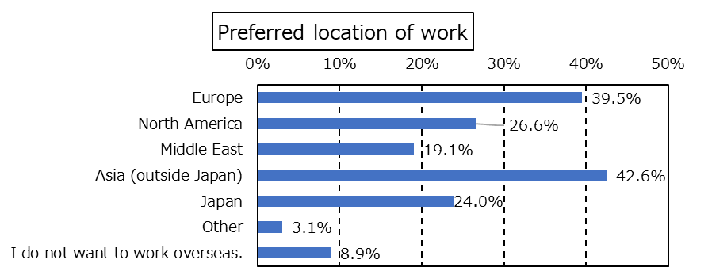

***By Country/Region***

〇 In UK, “Europe” (80.7%) accounts for the majority of all responses.

〇 In Hong Kong and Singapore, on the other hand, “Asia (outside Japan)” accounts for 60% respectively.

***By Employer to work for***

〇 In Finance and Insurance, “Europe” (46.2%) accounts for a large proportion.

***By Annual household income***

〇 Among households earning 30,000,000 JPY to less than 40,000,000 JPY, “Asia (outside Japan)” (50.5%) accounts for a large proportion.

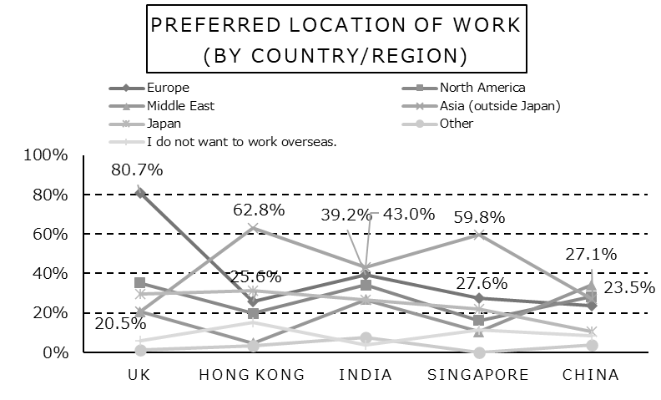



（２）The authority to make decisions about work transfers within the family　〔SA / n=425〕

Question：Who has the authority to make decisions about work transfers within the family?

***Overall***

〇 “More likely me” (90.1%) accounts for the majority of all responses, while “More likely my spouse” accounts for a small proportion (9.9%).

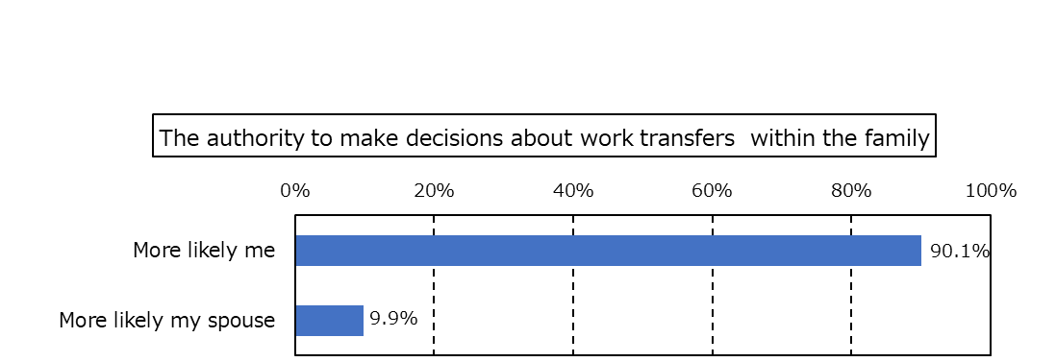

***By Country/Region***

〇 No specific tendencies are seen here.

***By Employer to work for***

〇 Among freelancers, “More likely my spouse” (21.1%) accounts for a large proportion.

***By Annual household income***

〇 “More likely my spouse” tends to accounts for a larger proportion of households with a higher income.





（３）Possibility of accompaniment by family members in case of working abroad　〔SA / n=425〕

Question：If you were to work abroad, would you be accompanied by family or go alone?

***Overall***

〇 Many responded “I would probably be accompanied by my family” (69.2%) while a few responded “I would probably go alone” (26.6%).

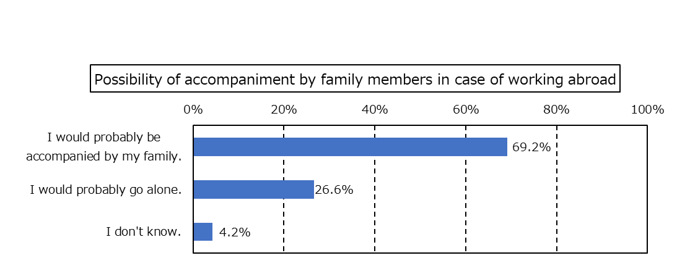

***By Country/Region***

〇 In India, “I would probably be accompanied by my family” (81.0%) accounts for a large proportion.

***By Employer to work for***

〇In Academic research, professional and technical services, “I would probably be accompanied by my family” (81.2%) accounts for a large proportion.

***By Annual household income***

〇 No specific tendencies are seen here.

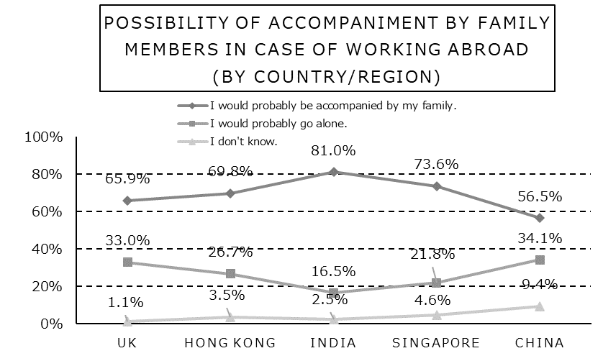



（４）Important factors in the living environment 〔SA / n=425〕

Question：What is most important to you about the living environment of your overseas workplace?

***Overall***

〇 “Residential environment” (63.5%) accounts for the largest proportion, followed by “Medical treatment environment” (25.4%).

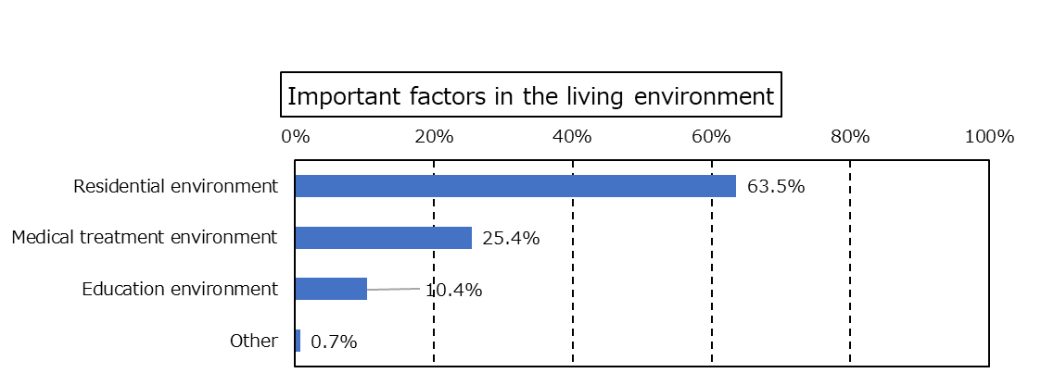

***By Country/Region***

〇 In UK, “Educational environment” (17.0%) accounts for a large proportion.

〇 In China, “Medical treatment environment” (51.8%) accounts for a large proportion, while ”Residential environment” (40.0%) a smaller.

***By Employer to work for***

〇 In Academic research, professional and technical services, “Medical treatment environment” accounts for a large proportion (42.0%) while “Residential environment” accounts for a small proportion (47.8%).

***By Annual household income***

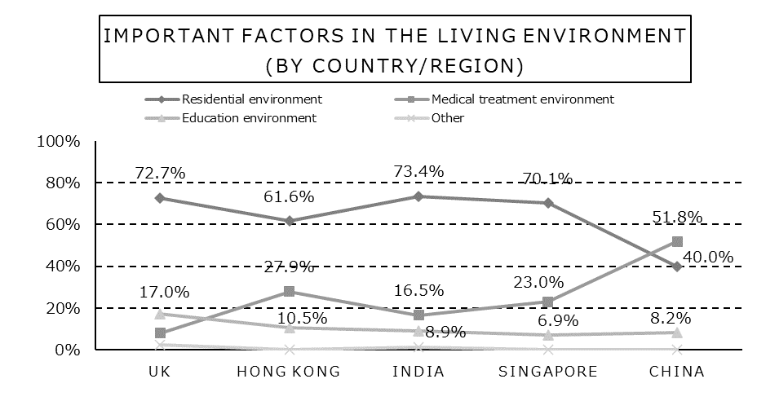〇 “Educational environment” tends to account for a larger proportion among households with a higher income.





（５）Significance of the educational environment in the location of transfer　〔SA / n=425〕

Question：How important is the educational environment of the place you are transferring to for you?

***Overall***

〇”Very important” (47.1%) and “Important” (34.8%) account for 80% together.

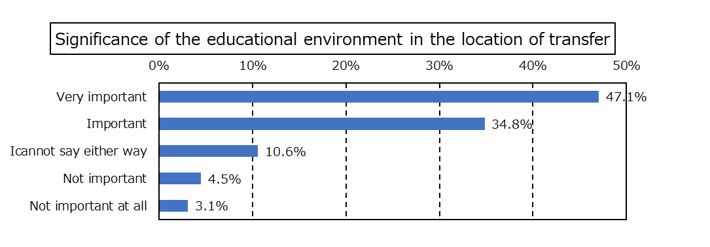

***By Country/Region***

〇 In UK, ”Very important” accounts for a large proportion (61.4%).

〇 In China, “I cannot say either way” accounts for a large proportion (22.4%).

***By Employer to work for***

〇 Among freelancers, “I cannot say either way” (21.1%) and “Not important” (10.5%) account for a large proportion.

***By Annual household income***

〇 “Educational environment” tends to account for a larger proportion among households with a higher income.

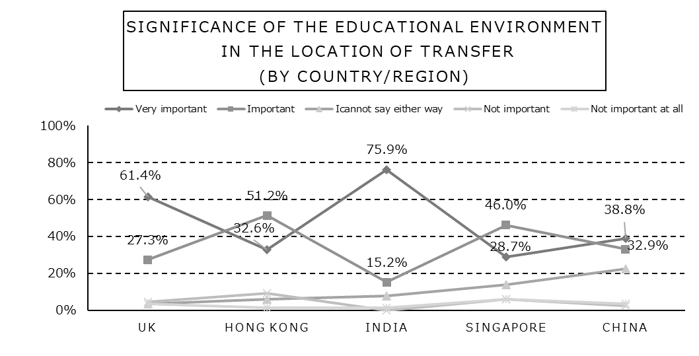



（６）Preference for schools for one’s children to attend in case of working overseas　〔SA / n=425〕

Question：Assuming you would like your child to attend school at your overseas workplace, would you prefer a local school or an international school?

***Overall***

〇 Many responded “International school” (64.9%), while a few responded “Local school” (30.6%).

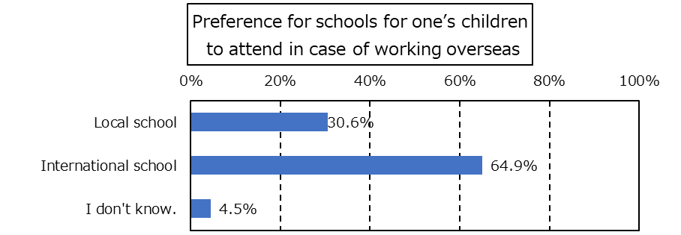

***By Country/Region***

〇 In India, “International school” accounts for a large proportion (78.5%).

***By Employer to work for***

〇 In Telecommunication, “International school” accounts for a large proportion (95.0%).

***By Annual household income***

〇 No specific tendencies are seen here.

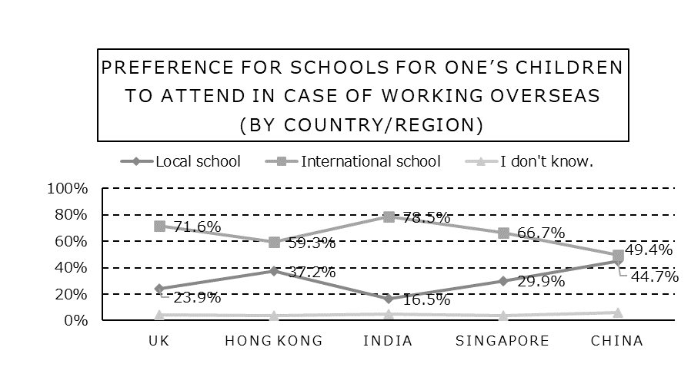





（７）Provision of assistance by the employer for international school attendance 〔SA / n=425〕

Question：Does your employer provide any assistance for international school attendance?

***Overall***

〇　“Yes” accounts for a large proportion (57.6%), while “No” a small proportion (31.5%).

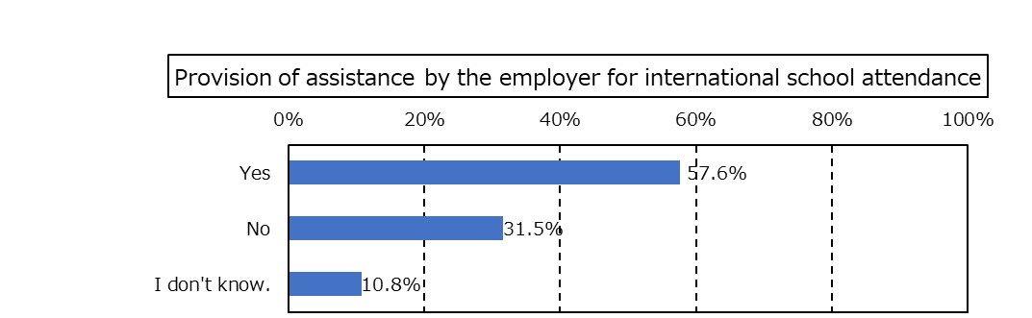

***By Country/Region***

〇 In China, “Yes” accounts for a large proportion (87.1%).

***By Employer to work for***

〇 In Academic research, professional and technical services, “Yes” accounts for a large proportion (72.5%).

〇 In Other, “Yes” accounts for a small portion (43.4%).

***By Annual household income***

〇 Among households earning 30,000,000 JPY to lee than 40,000,000 JPY, “Yes” accounts for a large proportion (68.4%).

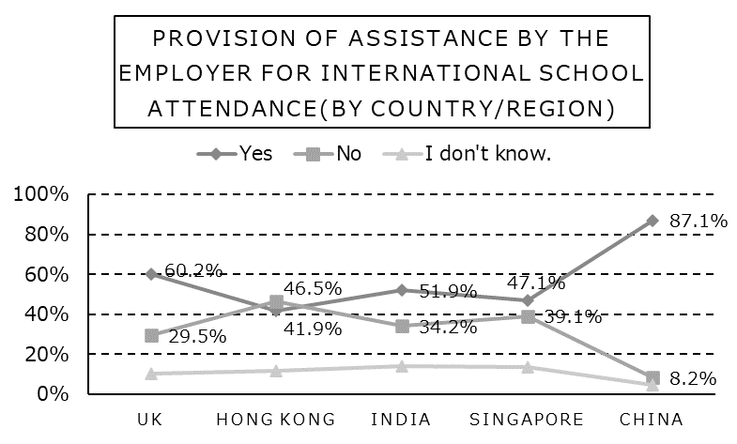





**The following question was directed to those who responded they “have children” for Question (6) Family structure**

４．Advancement to a higher education at university　〔MA / n=274〕

Question：What type of university would you like your child to attend?

***Overall***

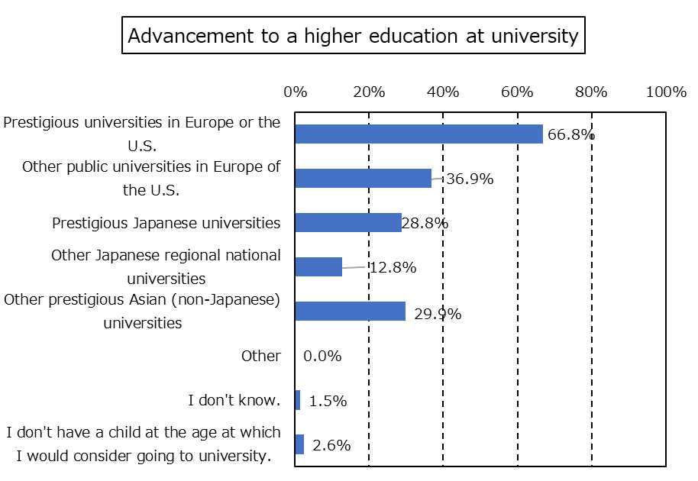〇 ”Prestigious Universities in Europe or the U.S. (Harvard, Yale, Princeton, Brown, Pennsylvania, Columbia, Dartmouth, Cornell, Oxford, Cambridge and UCL [University College London])” (66.8%) accounts for the most proportion, followed by “Other public universities in Europe or the U.S. (U.S. state universities, Russell Group in the U.K., etc.” (36.9%)

***By Country/Region***

〇 In UK, “Prestigious universities in Europe or the U.S.” accounts for a large proportion (77.9%).

〇 In India, "Prestigious universities in Europe or the U.S." (72.3%) accounts for the largest proportion, followed by "Other public universities in Europe or the U.S." (48.9%) and "Prestigious Japanese universities" (46.8%).

***By Employer to work for***

〇 In Academic research, professional and technical services, “Prestigious Japanese universities” accounts for a large proportion (37.8%).

***By Annual household income***

〇 Among households earning 40,000,000 JPY to less than 50,000,000 JPY, “Prestigious Japanese universities” (40.0%) and “Other Japanese regional national universities” (18.3%) account for a large proportion.





５．Other free comments and remarks

　Question：Please feel free to describe your expectations for international schools in Osaka and elsewhere in Japan, any improvements you would like to see, what elements you think are necessary in establishing a new school, how much you would be influenced by the surrounding international school situation when considering working abroad, and any other comments or suggestions you would like to make.







IV．Questionnaire

１．Japanese version

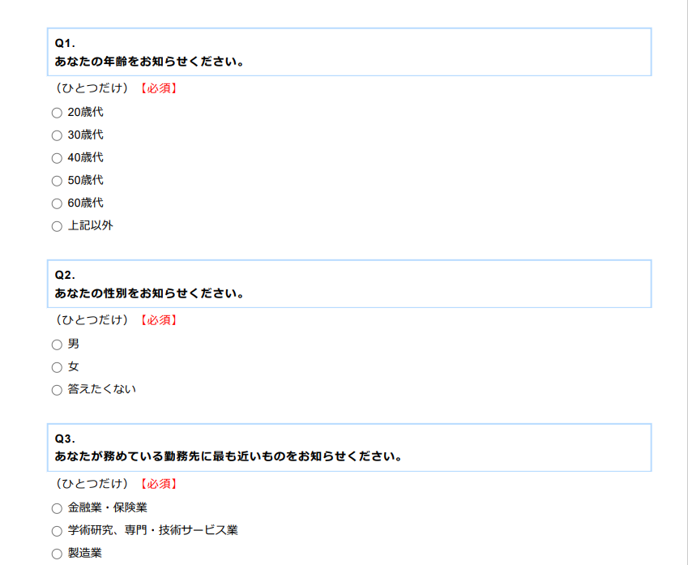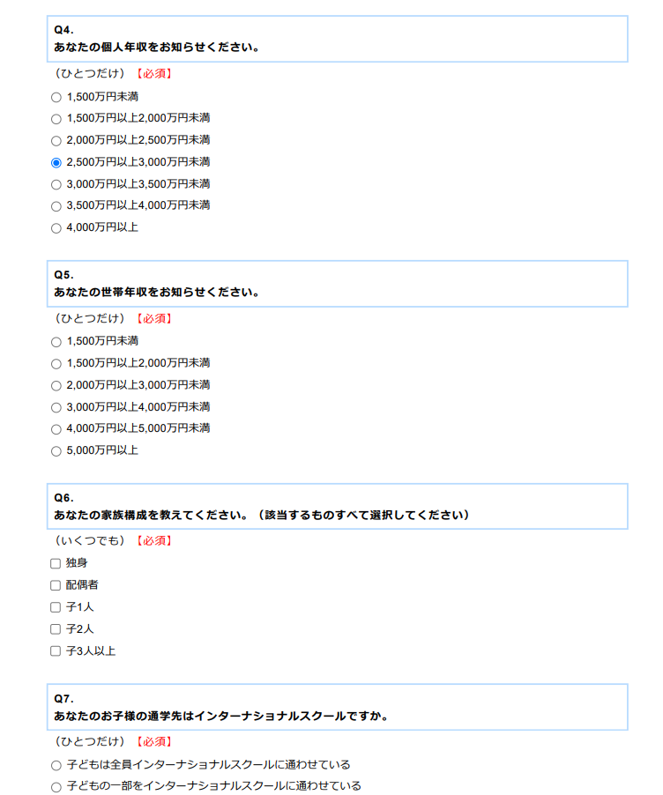

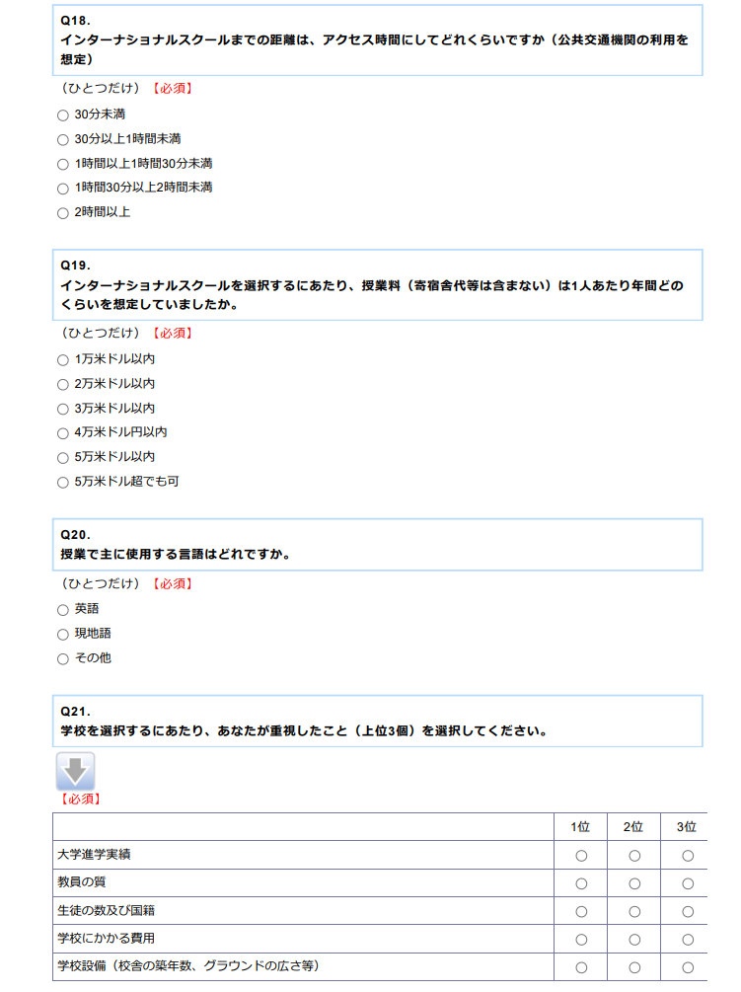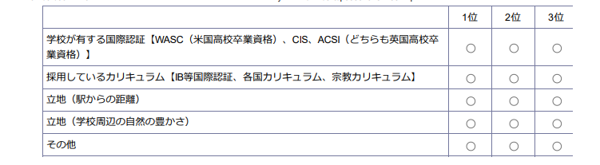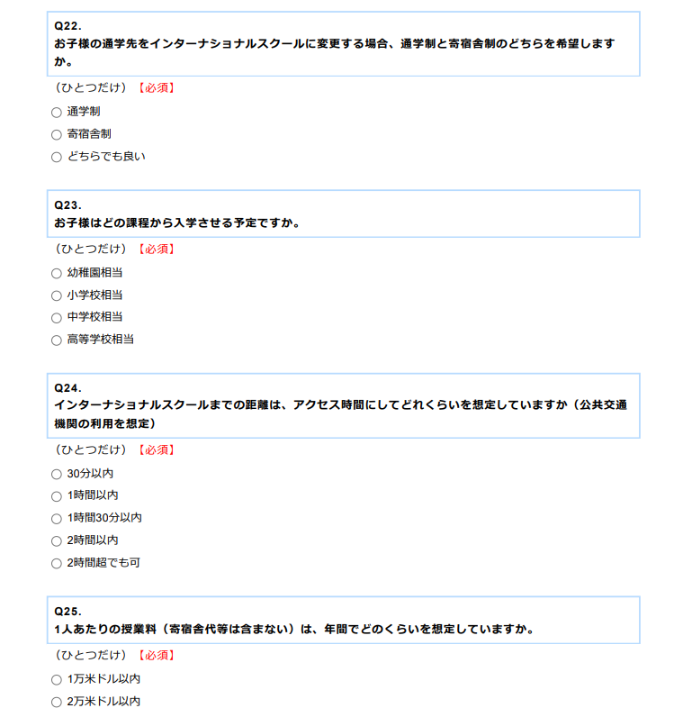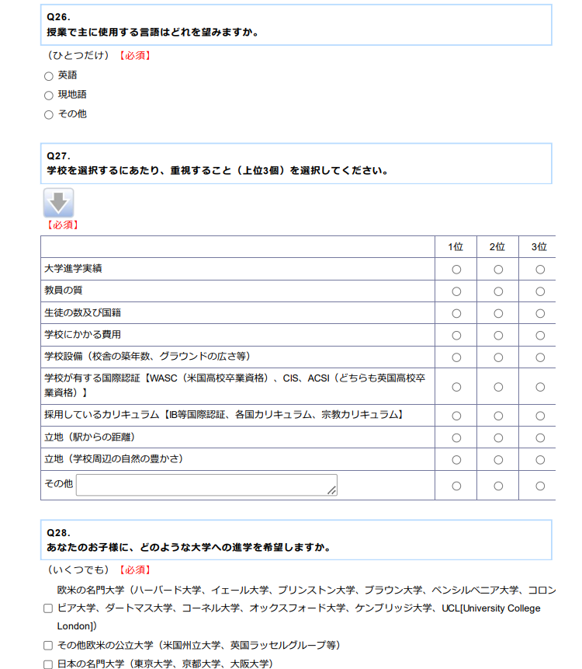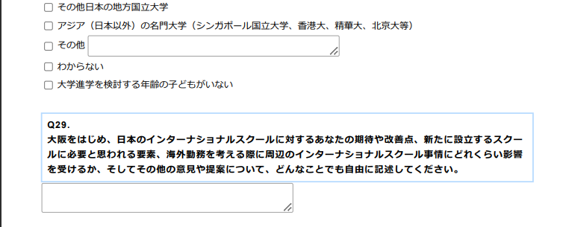

２．English version

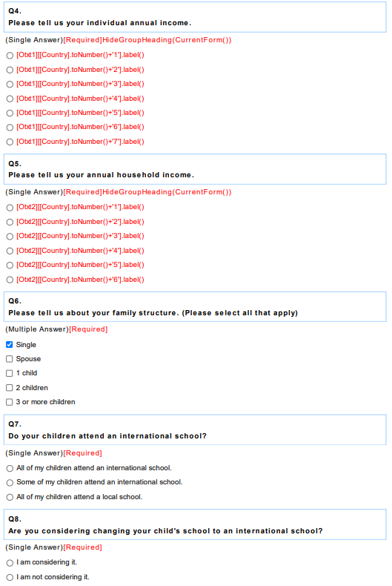

**〇　Less than JPY 15,000,000**

**〇　15,000,000 JPY to less than 20,000,000 JPY**

**〇　20,000,000 JPY to less than 25,000,000 JPY**

**〇　25,000,000 JPY to less than 30,000,000 JPY**

**〇　30,000,000 JPY to less than 35,000,000 JPY**

**〇　35,000,000 JPY to less than 40,000,000 JPY**

**〇　40,000,000 JPY or more**

**※調査を実施する際、現地通貨で表示**

**〇　15,000,000 JPY to less than 20,000,000 JPY**

**〇　20,000,000 JPY to less than 30,000,000 JPY**

**〇　30,000,000 JPY to less than 40,000,000 JPY**

**〇　40,000,000 JPY to less than 50,000,000 JPY**

**〇　50,000,000 JPY or more**

**※調査を実施する際、現地通貨で表示**



